

192.168.8.100/24

ADSL Modem

 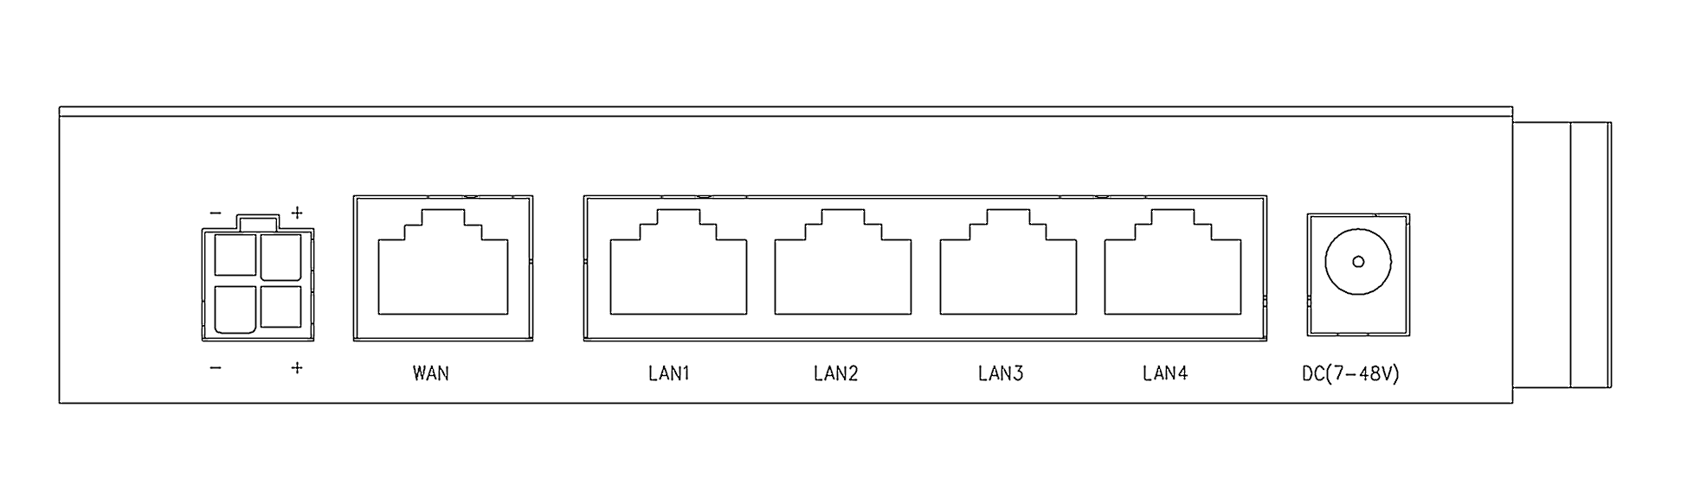

111.221.193.120/32

192.168.8.1/24

111.221.192.1/32

Gateway





111.221.192.1/16

192.168.8.100/24

Gateway



111.221.193.120/16

Router

192.168.8.1/24





10.6.165.1/24

10.6.165.2/24

192.168.8.100/24



Gateway

192.168.8.1/24



192.168.8.100/24



ADSL Modem

Gateway

111.221.193.120/32

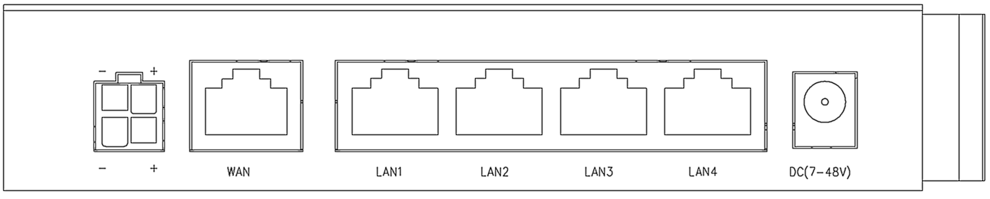

111.221.192.1/32

192.168.8.1/24

Router





192.168.8.100/24

Gateway

192.168.220.60/24



192.168.220.76//24

192.168.8.1/24





Router



192.168.10.1/24

192.168.10.120/24

Gateway(Bridge Mode)



192.168.8.1





Router

192.168.10.1/24

192.168.10.120/24

Gateway(AP Mode)



192.168.8.1





10.6.165.1/24

10.6.165.2/24

Gateway(LTE Bridge Mode)



192.168.8.1